Summer project presentation

Computational Geoscience group:

My project – description, goal, plan:

What:

* Simulation of CO2 in reservoir
* Flow relative to different properties of ambient fluid/rock
* Application area: optimize CO2 storage

Why:

* Understand flow behavior
* Minimize leakage of CO2 – mitigate impact on greenhouse effect
* CO2 simulations are applicable for large spatial and temporal scales. Not feasible to replicate very detailed structures of reservoir – instead need to run simulations for different possibilities. Thus, important to assess how much variations in rock structure affect CO2 flow.

How:

* Numerical discretization of governing equations
* Predict migration paths for CO2 => find locations that maximize long-term storage

Goal:

* Understand effect of different reservoir properties on CO2 flow and trapping
  + 4 trapping mechanisms – only structural + residual considered here
* Specific: Different configurations of low-perm layers
  + How much CO2 structurally trapped, leaked, residually trapped?
  + Any relations between volume ratios in different parts of domain and layer configurations?
* Eventually: Consider real reservoir (Sleipner) and assess generalization potential of previous analysis.

Relevant questions:

* For reservoirs of approx. same number low-perm layers, how large variation is there in trapped CO2 volume for different layer configurations?
* What is effect of DIFFERENT number of low-perm layers for temporal and spatial migration of CO2. Any particular relation between num low-perm layers and residually trapped CO2?

Tentative plan

* Get acquainted with MRST and stepwise implement a working code
  + How grids are generated, stored and accessed – important for creating complex stacks of layers.
  + How to make a model for the fluid/rock, set up a schedule defining the simulation procedure, compute an initial solution for the system, and finally merge these three components in a numerical solver
* Start with simple cases, gradually expand to make more complex
  + Great approach to observe effects of new components
  + Develop larger picture
* If time permits, choose a section of Sleipner injection field to run model on, and assess if results from synthetic simulations can be generalized, as real reservoirs certainly contain complex layered structures.
  + To what degree must the detailed structure be replicated?
  + What deviation between real data and modelled representation is acceptable, i.e. without too much inaccuracies in predicted migration paths.

Results so far…

Case 1 – impermeable layers

* Goal: Illustrate effect of buoyant forces in a reservoir of hydrostatic equilibrium
* Forced lateral migration under impermeable layers
* Leakage through open boundaries
* Buoyant migration - basis for spill-point analysis => estimate path CO2 follows from well to potential leakage point.

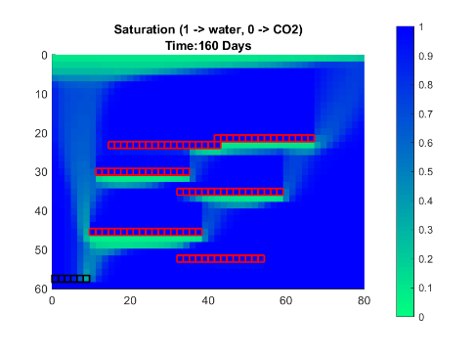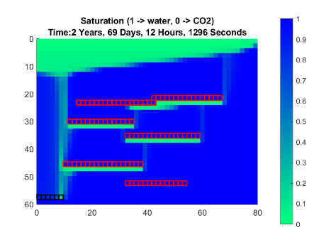

* Large vertical pressure gradient as injection starts
* Negative temporal pressure gradient at top -> CO2 lighter than water – exerts less pressure.
* 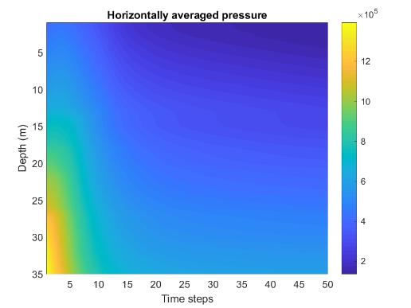

Case 2 – low-permeable layers

* Goal: How a heterogeneous permeability field affects flow behavior.
* Goal 2: Any difference in how much CO2 resides in interior for different NUMBER of low-perm layers?

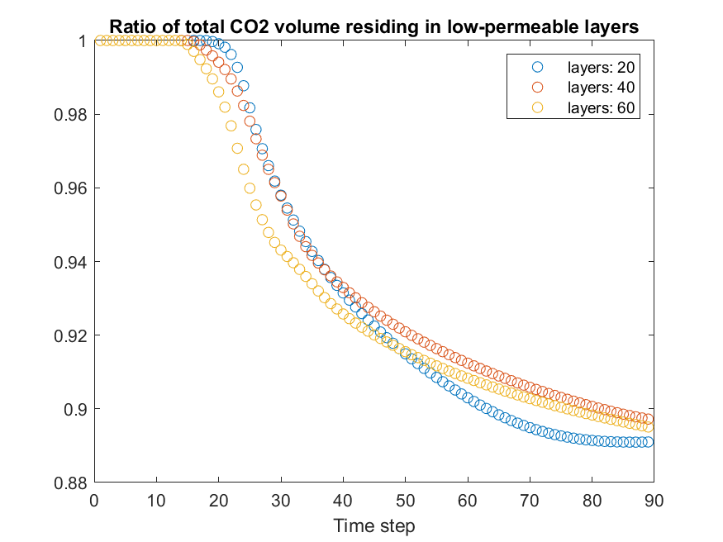

* Initially: All CO2 volume resides in interior
* Volume ratio starts decreasing once CO2 reaches caprock
* Decrease weakens when most of caprock region is filled – after 9 years, right plot below

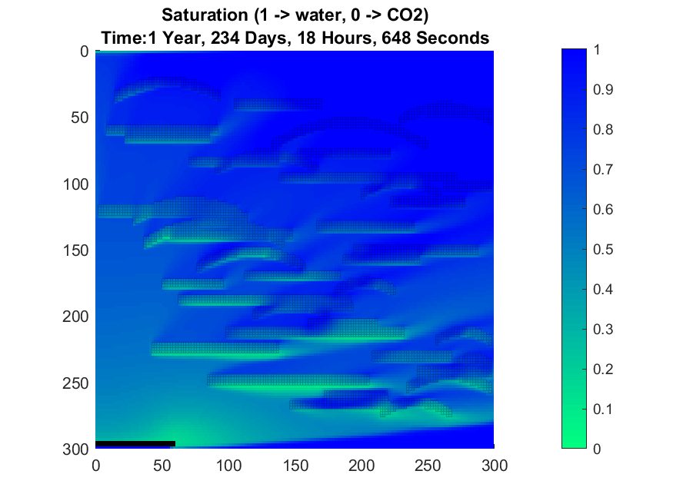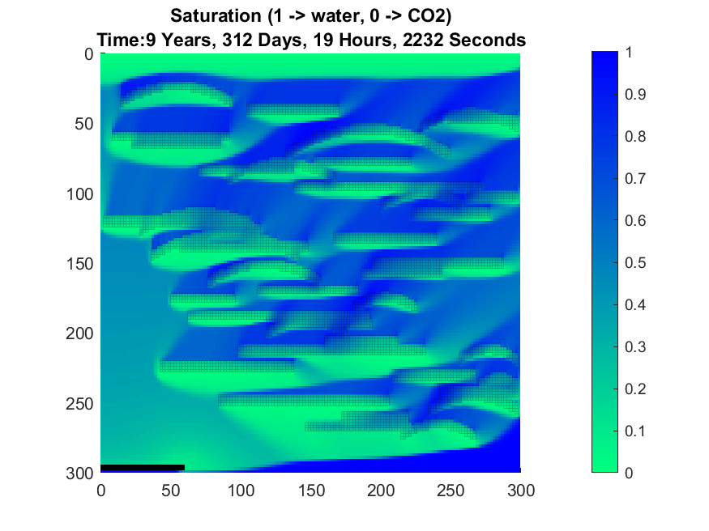

* Problem with simulation:
  + 2D domain: Pressure gradient across right open boundary very large 🡪 a lot of CO2 leaks out of domain
  + Fate of this CO2 is unknown – uncertainty!
    - Leakage? Structural trapping? Ambient conditions?

Case 3 – residual trapping + well shutoff

* Increase realism 🡪 account for residual trapping (immobilized CO2 inside pores) in addition to structural trapping (below imperm layers / caprock)
* Large leakage CAN be solved by extending simulation to 3D -> computationally expensive. Instead: shut off well around when leakage starts
  + To illuminate effect of leakage, two cases are done: minor leakage and no leakage.

Simulation set 1 – with leakage:

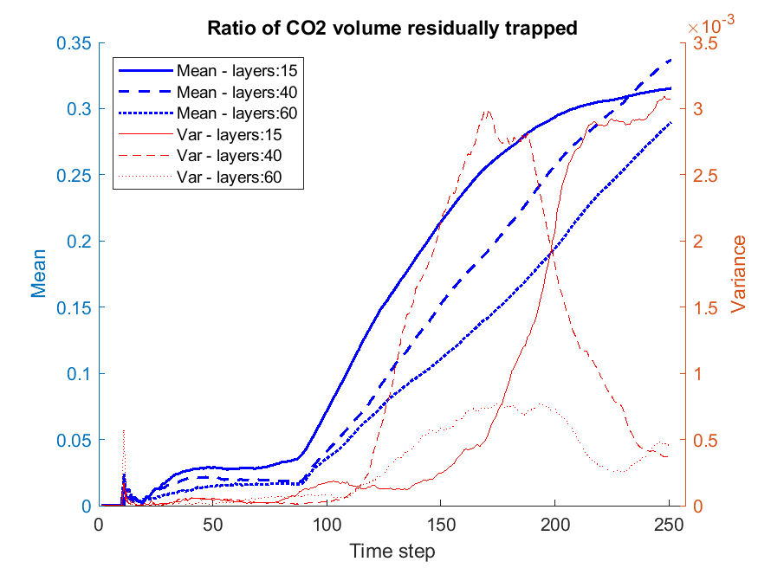

* Steady-state only for 15 layers
  + Less retardation 🡪 wake behind plume generated quicker 🡪 more res trap 🡪 steady-state reached earlier
* Lower interior volume ratio for low-perm layers
  + Less potential for residual trapping!
  + So less res trap partly explained by more leakage for few low-perm layers

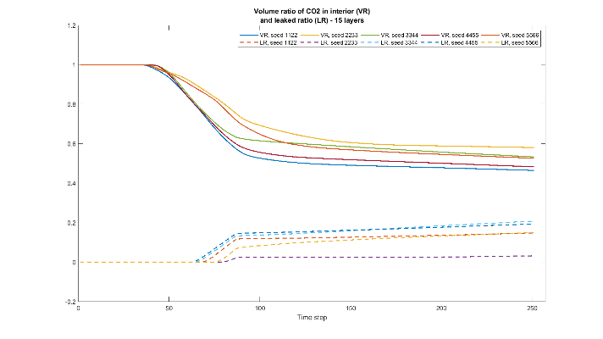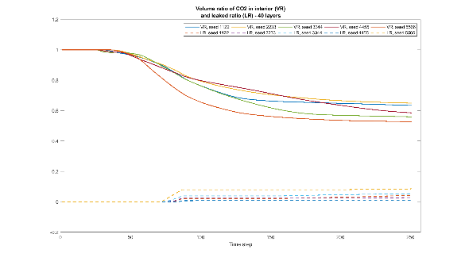



* Early time steps 🡪 low variance for all
* Middle time steps 🡪 large variance for many low-perm layers
  + Remaining parts of CO2 plume penetrate remaining low-perm layers 🡪 sensitive to configuration
* Late time steps -> large variance for few low-perm layers
  + Uncertainties in steady-state solution – sensitive to configuration!

Simulation set 2 – without leakage:

* Avoid leakage 🡪 shutoff done earlier
* Goal: Approach steady-state for more low-perm layers
* Problem: Retardation effect so strong 🡪 takes ages for weak mobilized CO2 to reach caprock or become immobilized.
  + Still of interest to compare to case with leakage

Results

* Vol ratio residually trapped increases way beyond that of sim-set 1
  + Early shutoff 🡪 less CO2 migrates to caprock and nothing leaked 🡪 potential for residual trapping larger – for all num layers!
* Early steady-state for 15 layers, approaching steady-state for 40 layers, still increasing for 60
* Net variance largest for 15 layers
* Variance large for final states for 60 layers, BUT cannot conclude from this, since steady state not reached yet.
* Pattern: Lower variance in residual trapping for many low-perm layers

Limitations + improvements

* Simulations in 2D:
  + Only a small part of entire flow picture
  + Some unphysical implications (e.g. large pressure gradient)
* Not all forces accounted for:
  + Capillary forces
  + Plan: Implement in next case study -> structural trapping may now occur in low-perm layers as well: if cap pressure not large enough CO2 will not invade water-filled low-perm layers
* Additional trapping mechanisms:
  + Dissolution + mineral (latter only significant after 1000 of years -> safe to omit)
* Other physical effects
  + Compressibility of fluid 🡪 varying density

-   Illustrate effect of buoyant migration in hydrostatic equilib​

* Forced lateral movement​
* Leakage through right boundary​
* Big initial vertical pressure gradient (injection pressure not balanced yet)​
* Temporal pressure gradient below caprock​
* CO2 lighter ◊ exerts less pressure than original water​

Embed low-perm layers in high-perm background rock.​

* How does heterogeneous permeability field affect CO2 migration?​
* Any notable variations between DIFFERENT num layers?​
* ​
* Results:​
* Init: all CO2 resides in interior until dt=20 ◊ accumulation under caprock ◊ decrease in VR​
* When caprock almost entirely filled ◊ decrease weakens (RIGHT PLOT BELOW)​
* Converge for 20 layers, still decrease for 40, 60 layers​
* ​
* Problem:​
* 2D: CO2 not much area to leave domain ◊ unphysically large pressure gradient ◊ much leakage​
* May not problem in itself ◊ may still be in reservoir, just outside our domain.​
* Problem IS ◊ no clue what happens to leaked CO2 – no knowledge of exterior conditions.

Goal:​

* Increase realism by accounting for residual trapping (+ structural trapping)​
* Mitigate issue of leakage:​
* Extend domain horizontally ◊ know fate of more of buoyant migrated CO2​
* Shut off well at point when leakage occurs​
* Combined BC to better illuminate effects of residual + structural trapping​
* ​
* Results:​
* Steady-state solution for 15 layers​
* Residual volume still increases for 40, 60 layers --> CO2 plume retarded by many low-perm layers --> wake from CO2 plume (which residual trapping originates from) also delayed​
* 15 layers: less steady-state residual ratio than 40, 60 layers​
* Lower interior volume ratio over time for 15 layers (due to more leakage and faster filling of caprock) --> less potential for residual trapping.​
* As mentioned, interested in finding a relation between number of low-perm layers and injected volume trapped by different mechanisms, so this is what has been made an attempt at in figure. Variance also computed for unique num layers --> essential for estimating uncertainty in our representation of layers in reservoir.​
* Ex: High variance for steady-state for 15 layers --> trapped volumes sensitive to layer configurations!​

Heterogen permeabilitet inni layers

* Gaussisk perm i lavpermeable lag.

Leverett J – function for capillary pressure

Hvor mye CO2 kan injiseres i reservoar uten å få lekkasje

* Hvor mye blir så residuelt/strukturelt fanget

Script:

* Start med en relativt liten rate, kjør simuleringer (for et gitt oppsett) i for-loop hvor man for hver iterasjon øker raten litt. Stopp iterering ved den modellen som først forårsaker lekkasje av CO2. Velg så injeksjonsraten fra forrige iterasjon – et godt estimat for maks volum CO2 som kan injiseres uten å få lekkasje. Beregn deretter andelen av dette volumet som fanges residuelt/strukturelt.

Sannsynlighet for lekker mer med flere lav-perm lag er liten

* Dette er bekreftet for case 3 (plots shutoff) 🡪 for samme injeksjonsrate over samme tid vil mer lekke ut ved høyre open boundary for 15 layers enn for 40/60 layers.

Open boundary på topp og høyre side.

* Er domain høyt nok vil i prinsippet alt kunne fanges residuelt + strukturelt før noe av plumen når topp av domain. Dette skal undersøkes i script!

Noen lav-perm lag, noen imperm

Heterogenitet (gaussisk) i et horisontalt lag som strekker seg ut over HELE domain.

Hysterese:

* S_max endres dynamisk med residual saturation.
* Hør med Stein om han har eksempelkode for dette.

PLAN:

* Heterogenitet i perm (gaussisk) i lav-perm lag.
* Capillary pressure (Leverett-J)
* Hysterese (residuell metning avhengig av max-saturation)
* Variabel permeabilitet (mean, var, korrelasjonsmengde)
* Null-lekkasje case:
  + Hvor mye CO2 kan injiseres uten lekkasje for gitt geologitype.
  + Åpen høyre-boundary og top-boundary
  + Lag for-løkke -> kjør helt til null lekkasje 🡪 hvor mye CO2 injisert da?
* Rotert grid
* 3D model